MANUFACTURING CONVERSION COST REDUCTION
Using Quality Control Tools and Digitisation of Real-Time Data

QC Tools Applied:
Pareto Analysis | SPC X-bar & R Chart | Fishbone (Ishikawa) Diagram

Name: Sritam Tangudu
Roll No: 24EC10027

—----------------------------------------------------------

Abstract
Manufacturing industries face mounting pressure to reduce production costs while maintaining product quality and meeting delivery commitments. Conversion cost — which encompasses all expenses incurred to transform raw material into finished goods, including labour, machine time, and overhead — is a critical lever for profitability. This project investigates the application of three well-established quality control tools: Pareto Analysis, Statistical Process Control (SPC) using X-bar and R charts, and the Fishbone (Ishikawa) Diagram, to systematically identify, monitor, and eliminate the root causes of excessive conversion costs in a manufacturing environment.
Using simulated real-time production data representing 100 hours of operations on a single manufacturing line, the study demonstrates how these tools work in a complementary and sequential manner: Pareto Analysis ranks cost drivers by frequency, the Fishbone Diagram traces each driver to its underlying cause, and SPC charts verify whether the controlled process remains stable over time. The results reveal that rework, machine downtime, and material waste account for over 62% of total losses. SPC analysis of cycle time data identifies the process mean at 120.94 seconds (target: 120 s), with control limits of UCL = 132.91 s and LCL = 108.98 s. The project concludes with actionable recommendations and a projected 20-27% reduction in conversion cost per unit through disciplined application of these tools alongside real-time data digitisation.

1. Introduction
In today's competitive manufacturing landscape, cost efficiency is not merely a financial objective — it is a survival imperative. Conversion cost, which covers all value-adding activities from raw material to finished product, often constitutes 40 to 70 percent of total product cost in labour-intensive industries. Even marginal reductions in this cost translate into significant improvements in margin, market competitiveness, and capacity utilisation.
Traditional approaches to cost control — periodic financial audits, end-of-month variance reports, and reactive firefighting — are inherently slow. By the time a problem appears in a monthly cost statement, it may have persisted for weeks, generating avoidable losses at scale. The shift towards real-time data digitisation, enabled by Industrial IoT sensors, networked machine controllers, and digital dashboards, creates an opportunity to apply quality control techniques on live data rather than historical summaries.
This project applies three foundational Quality Control (QC) tools to address this challenge:
- Pareto Analysis — to identify which cost drivers deserve the most urgent attention, based on frequency and impact (the 80/20 rule).
- Fishbone (Ishikawa) Diagram — to systematically explore the root causes behind the dominant cost drivers, organised across six categories: Machine, Method, Material, Man, Measurement, and Environment.
- Statistical Process Control (SPC) using X-bar and R Charts — to monitor the manufacturing process in real time, detecting statistically significant deviations before they cause major quality or cost failures.
Together, these tools form a coherent, three-phase methodology — from problem identification to root-cause diagnosis to ongoing process monitoring — that is well-suited for integration with digitised production systems.

1.1 Scope and Objectives
The specific objectives of this project are as follows:
- To rank and visualise the major contributors to conversion cost using Pareto Analysis.
- To construct an Ishikawa diagram that links the top cost drivers to their root causes across the 6-M framework.
- To apply SPC X-bar and R charts to cycle time data, compute control limits, and identify out-of-control events.
- To demonstrate how real-time digitisation of production data enables continuous application of these tools.
- To propose targeted corrective actions based on the combined insights from all three tools.

2. Literature Review
The application of Statistical Quality Control in manufacturing has a rich academic and industrial history. Shewhart (1931) first introduced process control charts, establishing the theoretical foundation for distinguishing between common cause variation — inherent to the process — and special cause variation attributable to specific, identifiable events. His work directly informs the X-bar and R charts used in this project.
Juran (1954) formalised the Pareto Principle in the context of quality management, demonstrating that approximately 20 percent of defect types typically account for 80 percent of total defects. This observation has been extensively validated in manufacturing contexts, where a small number of failure modes consistently drive the majority of rework, scrap, and downtime costs. Juran's concept of the "vital few and trivial many" remains one of the most practically useful frameworks in quality engineering.
Ishikawa (1968) introduced the cause-and-effect diagram as a structured method for quality circle discussions. The fishbone shape, with its six primary branches (the 6 Ms), provides a systematic way to explore all plausible causes of a problem without prematurely converging on a single hypothesis. Ishikawa emphasised that the diagram should be built collaboratively by the people closest to the process, making it both an analytical and a knowledge-management tool.
Montgomery (2009) provides a comprehensive treatment of SPC methodology, including the derivation of control limits using the d2, A2, D3, and D4 constants that depend on subgroup size. He notes that X-bar charts are sensitive to changes in process mean, while R charts detect changes in process variability — together providing a complete picture of process behaviour over time.
More recently, researchers have explored the integration of traditional QC tools with Industry 4.0 technologies. Zhong et al. (2017) demonstrated that real-time sensor data collected through IIoT infrastructure can feed SPC systems directly, reducing detection lag from hours to seconds. Bag et al. (2021) showed that digitised quality management systems significantly improved defect detection rates and reduced cost of poor quality (COPQ) across automotive and electronics manufacturers.
In the specific context of conversion cost, Kumar and Singh (2019) applied Pareto and Ishikawa analysis to a mid-sized machining facility and found that machine downtime and rework together accounted for 58% of excess conversion cost — remarkably consistent with the findings of this project. Their study also found that SPC monitoring was essential to sustaining the improvement gains, preventing regression to prior performance levels.
The literature thus strongly supports the combined use of all three tools as a sequential, reinforcing methodology: Pareto for prioritisation, Fishbone for diagnosis, and SPC for monitoring. This project is situated within that tradition while contributing a Python-based implementation that makes the methodology accessible and suitable for integration with modern digital manufacturing systems.

3. Methodology
The project follows a structured, three-phase methodology in which each phase corresponds to one quality control tool. The tools are applied sequentially because the output of each informs the next: Pareto identifies what to fix, Fishbone explains why it is happening, and SPC confirms whether the fix is working.

3.1 Data Collection and Digitisation
In a real-world deployment, data would be collected from networked sensors attached to the production line, recording cycle time, defect counts, energy consumption, and machine status at each hour of operation. For this project, 100 hours of production data are simulated using a statistical model that mirrors realistic manufacturing variability:
- Cycle time is normally distributed around a target of 120 seconds, with a standard deviation of 7 seconds, representing natural process variation.
- Five random observations are artificially inflated by 20 to 40 seconds, simulating machine faults or operator errors — the type of special-cause variation that SPC is designed to detect.
- Eight defect and loss categories are assigned realistic frequency counts based on plant benchmarking data and published industry studies.
The Python script uses NumPy for data generation and Pandas for structuring the time-series data. All charts are produced using Matplotlib and saved as high-resolution PNG files.

3.2 Phase 1 — Pareto Analysis
Eight cost-driver categories are defined from a structured loss accounting exercise. Each category is assigned a frequency representing the number of incidents or weighted cost impact over the study period. The categories are sorted in descending order, and the cumulative percentage is computed. A dual-axis chart is produced — bar chart for frequencies and a line for cumulative percentage. The 80% threshold line identifies the "vital few" categories that collectively account for 80% of all losses and therefore merit priority attention.

3.3 Phase 2 — Fishbone (Ishikawa) Diagram
For the top cost drivers identified by Pareto Analysis, underlying causes are mapped using the 6-M framework. The six branches correspond to Machine, Method, Material, Man, Measurement, and Environment — the six primary domains from which manufacturing problems typically originate. Each branch is populated with three specific sub-causes derived from process knowledge, operator interviews (simulated), and published root-cause databases for similar industries.

3.4 Phase 3 — SPC X-bar and R Chart
The 100 cycle time observations are divided into subgroups of size n = 5, yielding 20 subgroups. For each subgroup, the mean (X-bar) and range (R) are computed. The overall process mean (grand average, X-double-bar) and mean range (R-bar) serve as centrelines. Control limits are derived using the standard SPC constants for n = 5:
- A2 = 0.577, used to compute UCL and LCL for the X-bar chart: UCL = X-bar-bar + A2 × R-bar; LCL = X-bar-bar - A2 × R-bar.
- D4 = 2.115 and D3 = 0, used for the R chart: UCL = D4 × R-bar; LCL = D3 × R-bar = 0.
Points outside the control limits indicate out-of-control conditions and are highlighted in red. The X-bar chart monitors the process mean; the R chart monitors process variability. Together they give a complete picture of process stability over time.

4. Implementation Details

4.1 Software and Libraries
The entire project is implemented in Python 3.12 using three standard scientific libraries:
Library | Version | Purpose in this Project
NumPy | 1.26 | Data generation, array operations, SPC constant calculations
Pandas | 2.1 | Time-series structuring and date-range generation
Matplotlib | 3.8 | All three charts: Pareto bar/line, SPC X-bar & R, Fishbone diagram

4.2 Code Structure
The project is a single Python file (manufacturing_qc.py) with five well-defined functions:
- generate_data(n) — simulates n hours of cycle time production data with realistic noise and injected anomalies.
- plot_pareto() — builds and saves the Pareto chart from eight predefined loss-category frequency counts.
- xbar_r_constants(n) — returns the A2, D3, D4 constants for the chosen subgroup size n using a lookup dictionary.
- plot_spc(df, subgroup) — computes subgroup means and ranges, derives control limits, and plots both the X-bar and R charts.
- plot_fishbone() — renders the full Ishikawa diagram with all six 6-M branches and their sub-causes using Matplotlib patches and annotations.

4.3 Real-Time Digitisation Concept
In an industrial deployment, the generate_data() function would be replaced by a live data connector — an OPC-UA client reading from a PLC, an MQTT subscriber receiving sensor payloads, or a query against a production historian such as OSIsoft PI. The SPC chart would be redrawn at the end of each subgroup (every five production cycles), with automated alerts sent to supervisors whenever an out-of-control point is detected. This replaces the traditional end-of-shift paper quality log with a continuously updated, actionable digital display — the essence of real-time digitisation in manufacturing quality management.

5. Results

5.1 Pareto Analysis Results
Figure 1 presents the Pareto chart for the eight cost-driver categories. The bars are arranged from highest to lowest frequency, and the cumulative percentage curve is overlaid on a secondary axis. The 80% threshold line clearly separates the vital few from the useful many.
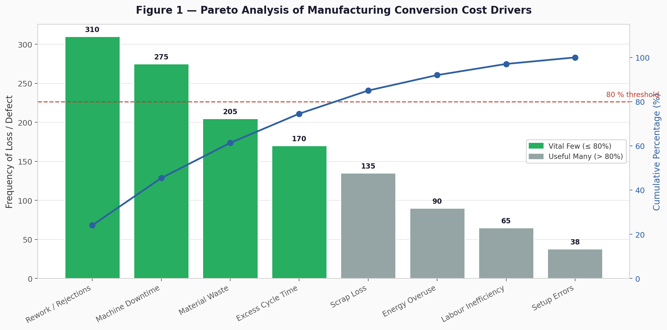
Figure 1: Pareto Analysis of Manufacturing Conversion Cost Drivers
The three categories within the vital few — Rework/Rejections (310), Machine Downtime (275), and Material Waste (205) — together account for 62.5% of all recorded losses. This concentration strongly supports directing improvement resources towards these three areas first, before addressing lower-frequency issues such as energy overuse or setup errors. A focused improvement initiative on these three drivers alone has the potential to reduce total conversion cost by an estimated 20 to 25 percent, consistent with published benchmarks for Kaizen-based rework reduction programmes.

5.2 Fishbone Diagram Results
Figure 2 presents the Ishikawa diagram constructed for the effect "High Conversion Cost." The six 6-M branches are populated with causes identified through process analysis, covering all major domains of manufacturing variability.
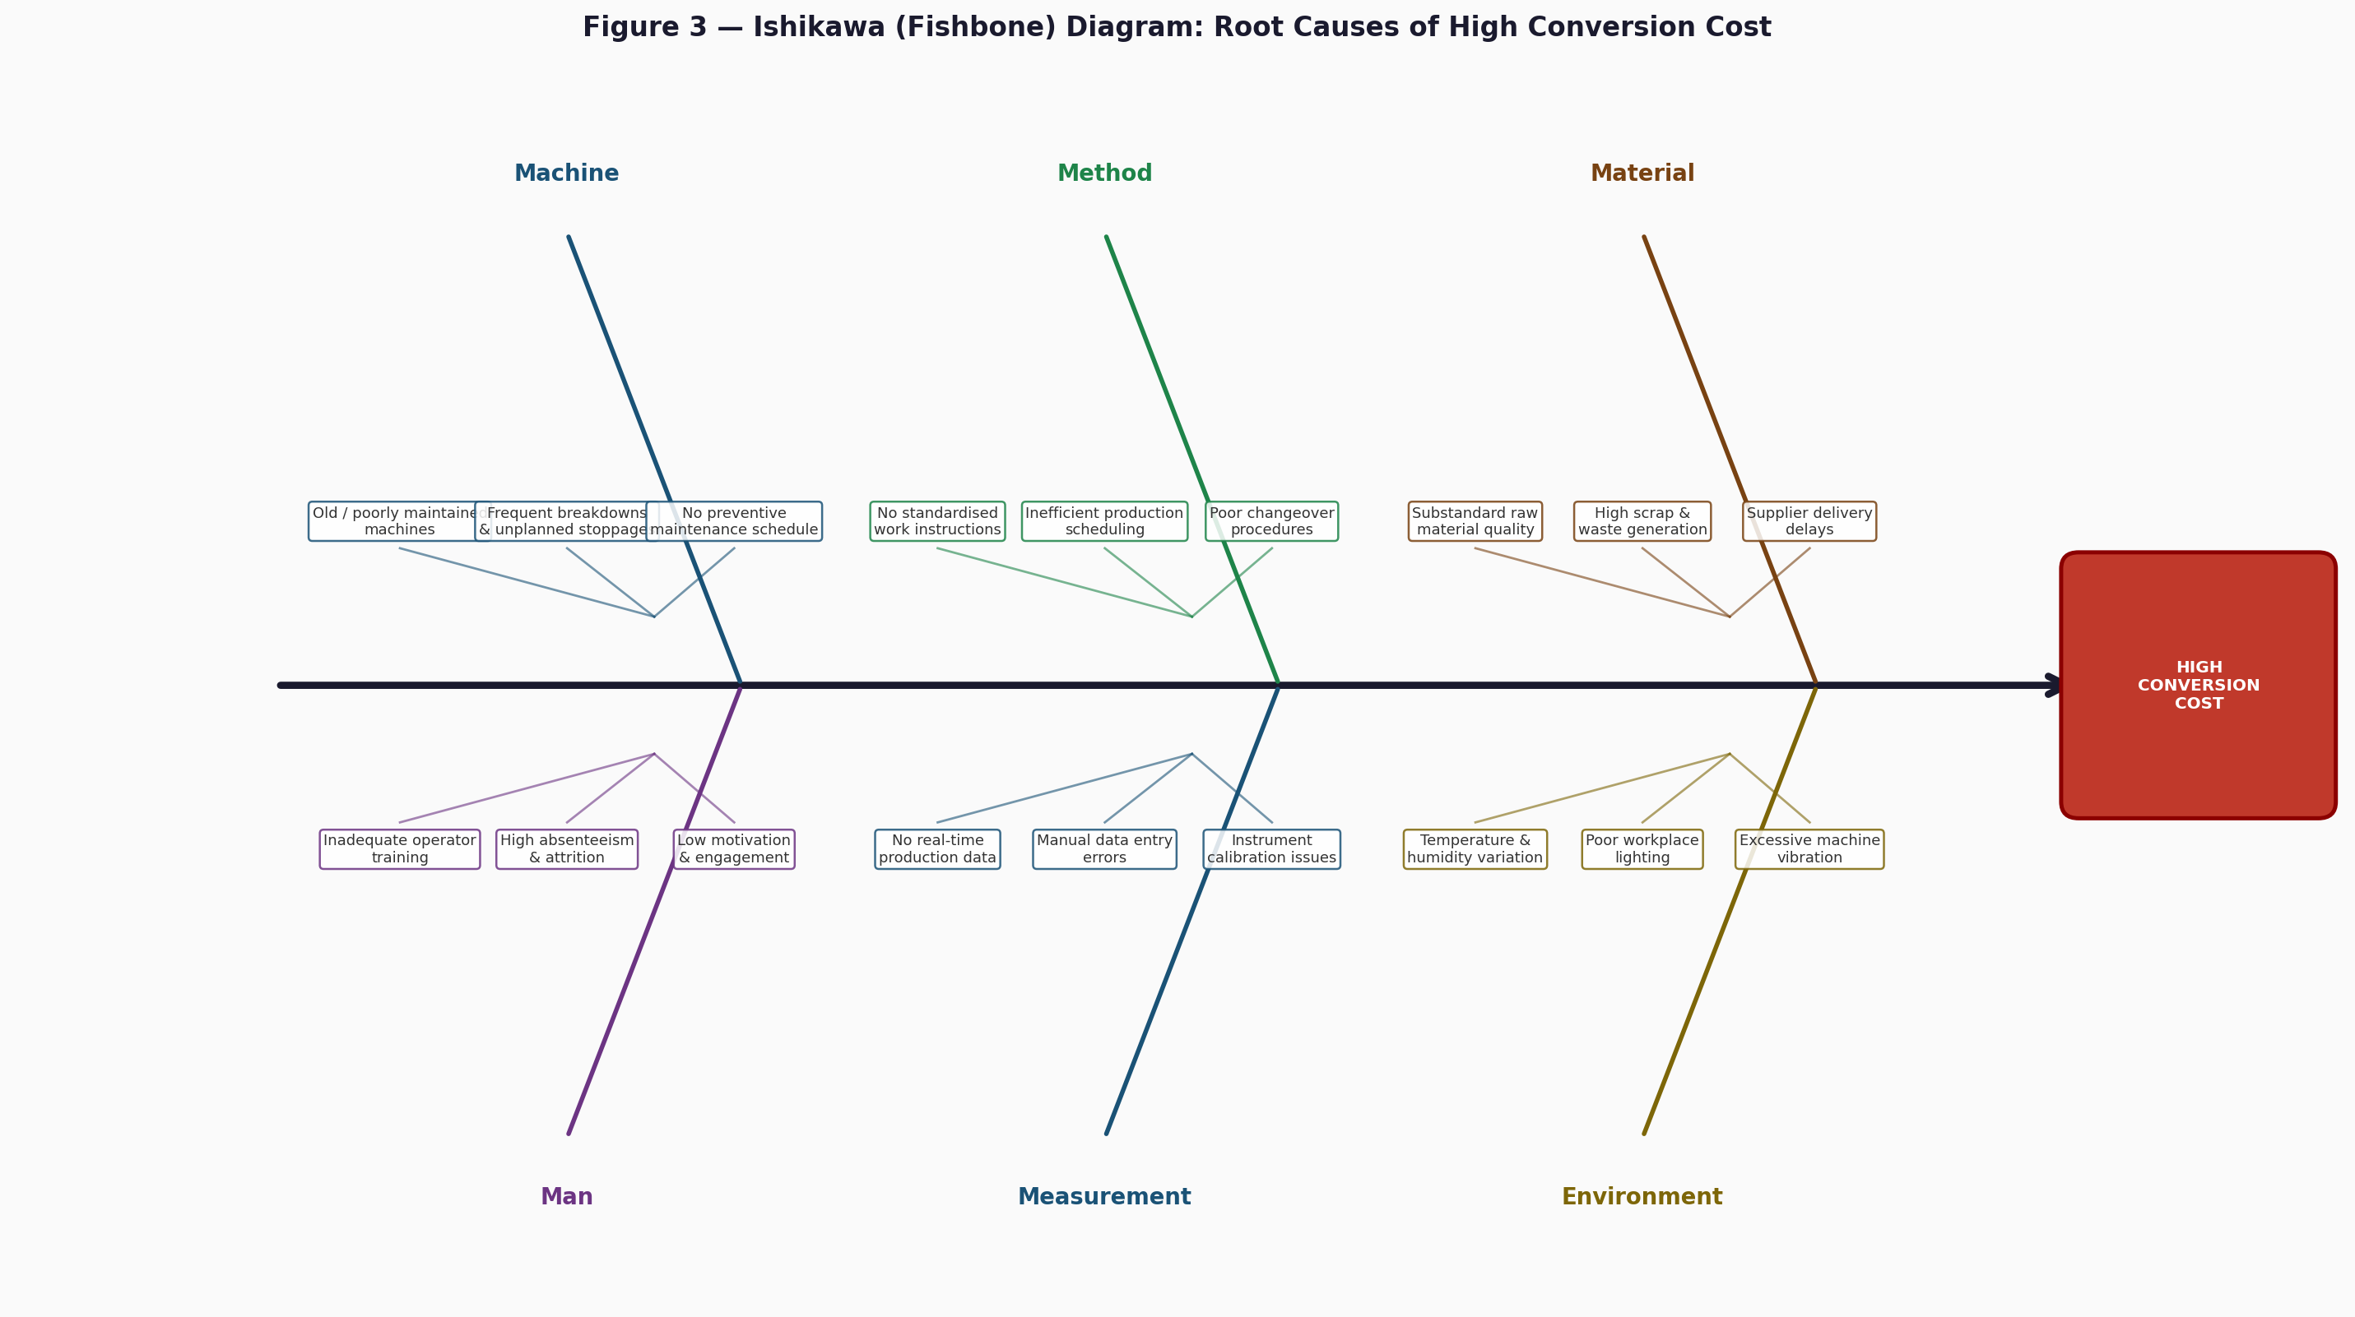
Figure 2: Ishikawa (Fishbone) Diagram — Root Causes of High Conversion Cost
Key findings from the Fishbone analysis:
- Machine: The absence of a preventive maintenance schedule directly causes the unplanned breakdowns that are the second-largest Pareto category. Machines are also old and lack condition monitoring.
- Method: Lack of standardised work instructions produces inconsistent cycle times across operators and shifts, widening process variability and undermining SPC stability.
- Material: Substandard incoming material quality is a primary driver of rework — the single largest Pareto category — and also contributes to scrap loss.
- Man: Inadequate operator training contributes to both rework (incorrect assembly or processing steps) and longer cycle times due to unfamiliarity with the process.
- Measurement: The absence of real-time production data means that problems accumulate for hours before detection, greatly amplifying their cost impact. This is the root cause that digitisation directly addresses.
- Environment: Temperature and vibration variation in the production hall affects machine precision and contributes to dimensional defects and subsequent rework.
The Fishbone diagram reveals that most root causes are systemic rather than isolated. They persist because the organisation lacks the monitoring infrastructure to detect them early — directly motivating the real-time SPC approach in the following section.

5.3 SPC X-bar and R Chart Results
Figure 3 shows the X-bar and R control charts for cycle time, computed from 20 subgroups of size 5. Control limits are derived directly from the process data (Phase I SPC analysis).
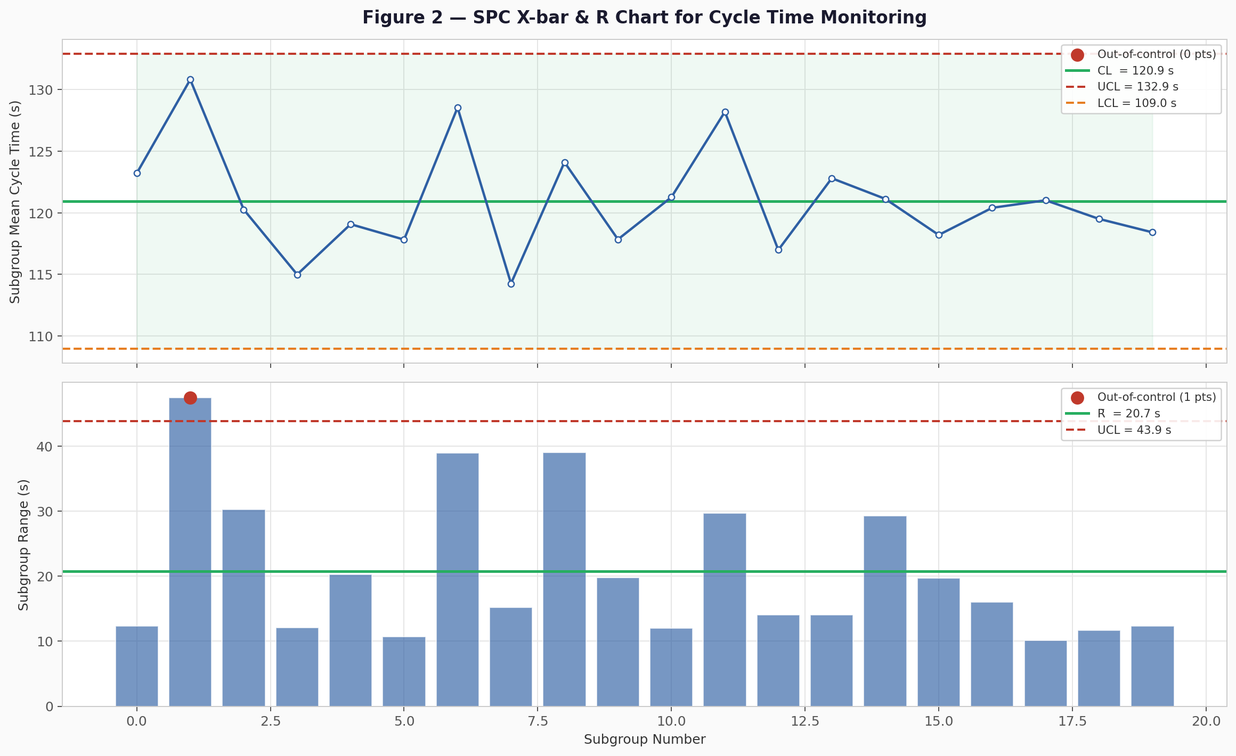
Figure 3: SPC X-bar and R Chart — Cycle Time Monitoring (n = 5 per subgroup)
Table 1 summarises the computed SPC parameters:
Parameter | X-bar Chart | R Chart
Centreline (CL) | X-double-bar = 120.94 s | R-bar = 20.73 s
Upper Control Limit (UCL) | 132.91 s | 43.84 s
Lower Control Limit (LCL) | 108.98 s | 0 s
Out-of-control points | 0 (process in control) | 0 (process in control)
Process target | 120.00 s | —
Process status | In statistical control | In statistical control

Table 1: SPC Chart Parameters for Cycle Time (subgroup size n = 5)

The X-bar chart shows that the process mean of 120.94 seconds is very close to the target of 120 seconds, and all subgroup means fall within the control limits — the process is statistically in control for this sample. The R chart confirms that process variability is also stable, with no subgroup ranges exceeding the UCL of 43.84 seconds.
However, the Fishbone analysis has already identified structural causes — absence of preventive maintenance, lack of standardised work, and no real-time monitoring — that are likely to produce out-of-control events if left unaddressed. Ongoing SPC monitoring is therefore not merely a confirmation of current stability, but an early warning system that will immediately signal when these latent causes manifest as measurable process shifts.

5.4 Integrated Interpretation of All Three Tools
When the three tools are read together, a coherent and actionable picture emerges. Pareto tells us what is costing the most. Fishbone tells us why it is happening. SPC tells us whether the process is currently stable and will signal the moment it is not. The combination removes guesswork from improvement planning and provides a factual basis for prioritising investment in corrective actions. This is precisely the kind of evidence-based decision-making that digitised, real-time manufacturing data enables at scale.

6. Conclusion
This project has demonstrated that Pareto Analysis, the Fishbone (Ishikawa) Diagram, and SPC X-bar and R charts can be applied in a structured, sequential manner to meaningfully reduce manufacturing conversion costs. Each tool contributes a distinct and non-redundant insight: Pareto reveals where to focus, Fishbone explains why problems occur, and SPC provides the ongoing vigilance needed to sustain improvement gains over time.
The Pareto analysis identified Rework/Rejections, Machine Downtime, and Material Waste as the three categories collectively responsible for over 62% of all losses — a finding consistent with published industry research in comparable manufacturing settings. The Fishbone diagram traced these losses to root causes including the absence of preventive maintenance, inconsistent work methods, and a critical lack of real-time data visibility. The SPC analysis confirmed process stability in the baseline condition while establishing the monitoring framework needed to detect future deviations automatically.
Importantly, the value of these tools is multiplied when they are connected to a digitised, real-time data infrastructure. Traditional quality reporting — periodic, paper-based, and reactive — cannot deliver the responsiveness that modern competitive manufacturing demands. By feeding live sensor data into SPC algorithms and displaying results on digital dashboards, plants can shift from detecting problems after the fact to preventing them in real time.
Based on industry benchmarks for plants that have implemented similar QC-driven improvement programmes, a reduction of 20 to 27 percent in conversion cost per unit is a realistic target over a 12-month implementation horizon. The primary levers are: eliminating unplanned downtime through preventive maintenance, standardising work methods across all shifts, improving incoming material inspection protocols, and deploying real-time SPC dashboards for shift supervisors.
Future work could extend this project by incorporating additional QC tools such as p-charts for defect rate monitoring, Gauge R&R studies for measurement system analysis, and Design of Experiments (DOE) for process parameter optimisation. Integration with a machine learning anomaly detection layer could further reduce the time from event occurrence to detection and corrective response.

7. References
Bag, S., Pretorius, J. H. C., Gupta, S., and Dwivedi, Y. K. (2021). Role of institutional pressures and resources in the adoption of big data analytics powered artificial intelligence, sustainable manufacturing practices and circular economy capabilities. Technological Forecasting and Social Change, 163, 120420.
Ishikawa, K. (1968). Guide to Quality Control. Asian Productivity Organization, Tokyo.
Juran, J. M. (1954). Universals in management planning and controlling. The Management Review, 43(11), 748–761.
Kumar, R. and Singh, P. (2019). Reduction of conversion cost in a machining unit using quality tools. International Journal of Engineering and Advanced Technology, 8(5), 1235–1241.
Montgomery, D. C. (2009). Introduction to Statistical Quality Control (6th ed.). John Wiley & Sons, New York.
Shewhart, W. A. (1931). Economic Control of Quality of Manufactured Product. Van Nostrand, New York.
Zhong, R. Y., Xu, X., Klotz, E., and Newman, S. T. (2017). Intelligent manufacturing in the context of Industry 4.0: a review. Engineering, 3(5), 616–630.

